#

**Agoraphobia Group**

**Session 2: The Body**

In today’s session we discussed the impact of agoraphobia on the body, its role in the ‘vicious cycle’ as outlined below, and some of the things we can do to manage the physical symptoms of Agoraphobia.

**Fight or Flight Response**

When we are sense danger or threat (either real or perceived) we experience a strong emotion called fear which leads us to feel anxious. Fear and anxiety trigger a chain of automatic events in our bodies that prepare us for action. This is often called the ‘fight or flight’ response and can be traced back to our need for survival in the past. The ‘fight or flight’ response is a normal and helpful response when we are faced with immediate physical danger or threat. However, it is unhelpful when it is switched on if the threat is low or happens in a situation when there is no ‘real’ threat e.g. when you’re speaking in front of people or queuing up in the supermarket.

Therefore when we are faced with our agoraphobic situation, the fight or flight system is activated and our bodies go through a series of physical changes. These physical changes are preparing our bodies to either fight or run away from the danger.

**Andrews Example of the vicious cycle**

**Agoraphobic Situation**

Standing at the bus stop waiting to go to college

**Thoughts**

What if I can’t get off the bus?

What if I collapse and faint?

What if people look at me and laugh?

**Physical Sensations**

Increased sweating

shaky

increased heart rate

muscle tension

**Feelings**

Anxious

worried

dread

**Behaviour**

loss of focus and concentration

leaves bus stop

goes home

**Exercise 2.1 What physical changes do you notice in your body**

What changes do you notice in your body when you are feeling panicked & anxious and in what situations do these changes happen?

|  |
| --- |
|  |
|  |
|  |
|  |

The most common physical symptoms of fight or flight response include heart palpitations, chest tightness, rapid breathing, sweating, hot flushing, dry mouth, numbness and pins & needles.

**Common Physical Sensations (see diagram)**

1. **Your heart beats faster**: it is the hearts job to carry oxygen around the body. By beating, faster heart is able to take the oxygen to where it is needed the most. i.e. legs to run faster.

Side effects –tightness in the chest, remember this is a normal response, you are not having a heart attack

1. **Your breathing quickens and becomes shallow:** This allows you to take in more oxygen so that it can be carried via the bloodstream to your lungs, arms and legs via Side effects- may be chest pain, breathlessness, choking feeling, blurred vision. Although you may feel dizzy **you will not faint**. To faint your blood pressure has to drop – when we are anxious, because our hearts beat faster, our blood pressure is temporarily raised.
2. **Your muscles start to tense**: This happens to make sure we can stand and fight or run away, ready for action.
3. **Increased Sweating**: Sweating cools you down , therefore making you more effective in your ability to run away or fight.
4. **Nausea, dry mouth and pins and needles**: this is a result of your blood being diverted to the areas which require oxygen throughout the flight or flight response.

**Panic attack or heart attack? Know the difference.**

It is crucial to remember that a panic attack is **not** a heart attack. The main difference is that a person who is in the midst of a heart attack often vomits. A person suffering through a panic attack may feel sick but vomiting is very rare. Furthermore, people experiencing a heart attack describe the chest pain as crushing with the pressure felt in the centre of the chest which may extend to the left arm, neck and back. In contrast, a person who is suffering a panic attack describes the chest pain as sharp, felt just over the heart. Also, the symptoms of panic attack usually start wearing off after 10 minutes when you start a process of recovery. Finally, heart attack victims will rarely experience the rapid breathing that accompanies panic attacks.

Panic attacks can be very stressful and uncomfortable but they **are not dangerous.** they will cause you **no harm.**

**Exercise 2.2 What do you do to manage your physical symptoms of anxiety**

What changes do you notice in your body when you are feeling panicked & anxious and in what situations do these changes happen?

|  |
| --- |
|  |
|  |
|  |
|  |
|  |
|  |
|  |

**Ways to Manage the Physical Symptoms of Anxiety**

Remember when the fight or flight system is activated, it release adrenaline, this signals to our brain that we are in danger, this then triggers the physical changes. By gaining control over your physical symptoms, you are able to signal to the brain that there is no danger.

**Controlling your breathing**

One of the most common symptoms of anxiety is hyperventilation or over-breathing – breathing too fast and taking in more oxygen than you need. This can cause tightness of the chest and lots of other unpleasant sensations such as feeling faint. Breathing is one of the easiest physical sensations to control by yourself.

**Exercise: controlled Breathing**

* Place one hand on your chest, and one on your stomach
* Imagine a balloon in your stomach
* Breathe in counting 1…2…3 slowly (you should notice when you breathe in, your stomach should move out slightly as if the balloon was inflating)
* Breathe out counting 1…2…3 slowly (you should notice when you breathe out your stomach should move in slightly as if balloon was deflating)

You should practise calming your breathing many times before using it to control the symptoms of anxiety – you may find it takes many attempts before you are able to breathe calmly when you feel panicky. It is a good idea to practise this technique when you do not feel anxious so that you can use it easily when you do experience anxiety.

**\**Alterative breathing exercise is available at the end of the workbook.***

**Relaxation:**

Relaxation is a very useful way of coping with the physical symptoms of anxiety. When someone has been anxious for a long time they are often unaware of the tension in their muscles, or the knot in their stomach, which is a result of the body’s reaction to stress. When we are stressed or anxious the muscles in our bodies tense up and this can cause uncomfortable bodily feelings like headache, backache, or tightness in the chest. The aches and pains of tension can cause mental worry, making us even more anxious and tense. People who are anxious and tense are often tired.

**Progressive Muscular Relaxation** is one of the easiest forms of relaxation and involves tensing and relaxing all the major muscle groups in the body. Learn more on how to practise this technique by listening to your **relaxation CD or by reading the written instruction at the end of the workbook.**

**Apps**

5 Minute Relaxation’ and ‘Breathe2Relax’

Wellbeing website: <http://wellbeing-glasgow.org.uk/audio-resources/>

**Home Practice**

* practice the controlled breathing, Progressive muscular relaxation.
* use the relaxation diary

**Breathing Exercises**

**Mindful Breathing**

The primary goal of mindful breathing is simply a calm, non-judging awareness, allowing thoughts and feelings to come and go without getting caught up in them.

* Sit comfortably, with your eyes closed and your spine reasonably straight.
* Bring your attention to your breathing.
* Imagine that you have a balloon in your tummy. Every time you breathe in, the balloon inflates. Each time you breathe out, the balloon deflates. Notice the sensations in your abdomen as the balloon inflates and deflates. Your abdomen rising with the in-breath, and falling with the out-breath.
* Thoughts will come into your mind, and that’s okay, because that’s just what the human mind does. Simply notice those thoughts, then bring your attention back to your breathing.
* Likewise, you can notice sounds, physical feelings, and emotions, and again, just bring your attention back to your breathing.
* You don’t have to follow those thoughts or feelings, don’t judge yourself for having them, or analyse them in any way. It’s okay for the thoughts to be there. Just notice those thoughts, and let them drift on by, bringing your attention back to your breathing.
* Whenever you notice that your attention has drifted off and is becoming caught up in thoughts or feelings, simply note that the attention has drifted, and then gently bring the attention back to your breathing.

It's okay and natural for thoughts to enter into your awareness, and for your attention to follow them. No matter how many times this happens, just keep bringing your attention back to your breathe.

**Square breathing**

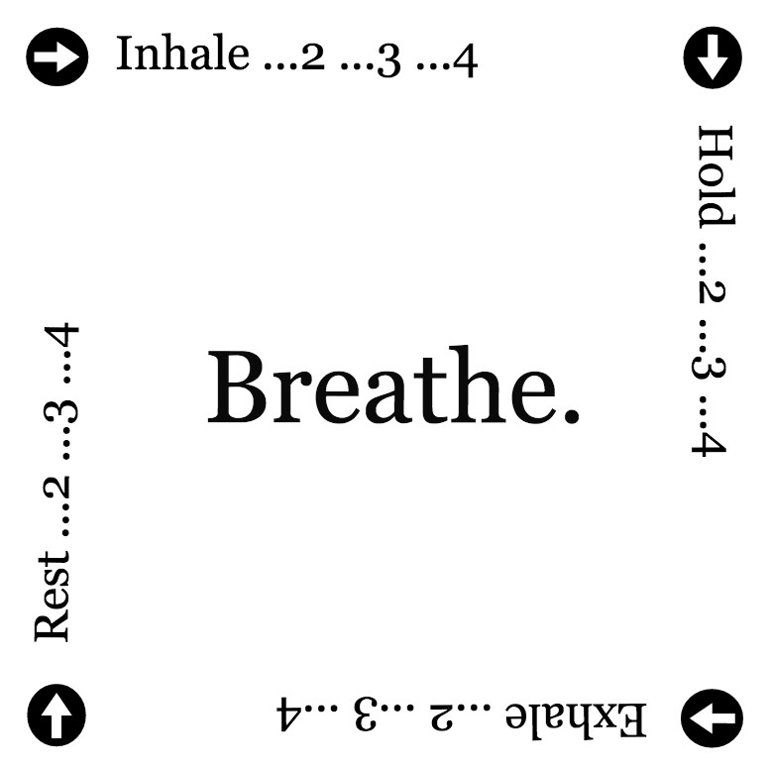

**Progressive Muscle Relaxation**

Our bodies respond automatically to stressful situations and thoughts by becoming tense. The opposite relationship also works: a good way of relaxing the mind is to deliberately relax the body. In a progressive muscle relaxation each muscle group is tensed in turn, and the tension is then released. This relaxes the muscles and allows you to notice the contrast between tension and relaxation. Relaxation should be enjoyable so if any part of the exercise is too difficult skip it for the moment. If you have any injuries you may wish to leave out that part of the exercise.

**Preparation**

Lie down flat on your back, on a firm bed, a couch, or on the floor. Support your head and neck with a pillow or cushion. Alternatively sit in a comfortable chair with your head well-supported. Close your eyes if you are comfortable doing so.

**Instructions**

Focus your attention on different parts of your body in sequence. Go through the

sequence three times:

*1) Tense & release: Tense that body part, hold it for a few moments, then relax*

*2) Lightly tense & release: Tense that body part with just enough tension to notice, then relax*

*3) Release only: Just pay attention to each muscle group and decide to relax it*

**Recommended sequence**

**1** Right hand & arm

(clench the fist & tighten the muscles in the arm)

**2** Left hand & arm

**3** Right leg

(tense the leg, lifting the knee slightly)

**4** Left leg

**5** Stomach & chest

**6** Back muscles

(pull the shoulders back slightly)

**7** Neck & throat

(push the head back slightly into the pillow/surface)

**8** Face

**Relaxation Diary**

|  |  |  |  |  |  |  |
| --- | --- | --- | --- | --- | --- | --- |
| **Date** | **Day** | **Time** | **Place** | **Relaxation Exercise** | **How relaxed before** | **How relaxed after** |
| **0=not relaxed at all/10=really relaxed** | |
|  |  |  |  |  |  |  |
|  |  |  |  |  |  |  |
|  |  |  |  |  |  |  |
|  |  |  |  |  |  |  |
|  |  |  |  |  |  |  |
|  |  |  |  |  |  |  |
|  |  |  |  |  |  |  |
|  |  |  |  |  |  |  |
|  |  |  |  |  |  |  |
|  |  |  |  |  |  |  |

