RELATIONSHIPS AND MENTAL HEALTH COURSE – WEEK FIVE
Is Your Relationship Toxic?
- When you are with the person, or after you are with the person, you feel physically or emotionally drained
- When you are with the person, or after you are with the person, you feel bad about yourself
- You feel like you are always giving and don’t get anything back or the other person is always taking and does not give anything back
- You feel shunned or like an outsider and don’t feel accepted for who you are
- You feel isolated from supportive friends and family as the other person does not want you to see them
- You feel emotionally or physically unsafe
- You are afraid
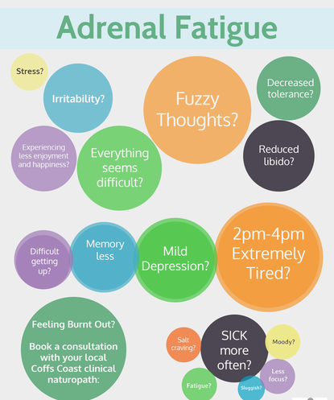
People in toxic relationships are at a greater risk of:-
- developing heart problems
- dying from a heart attack
- dying from a stroke
- developing chronic inflammation
- developing adrenal fatigue

Tips to Manage Toxic Relationships
- Accepting the relationship as it is can lead to a reduction in stress instead of trying to change the other person
- Set boundaries within the relationship – you can’t change someone else but you can change how you deal with the situation
- Seek professional support e.g. a relationship counsellor to work through relationship problems
- End the relationship – sadly if the other person’s behaviour is intolerable this may be an option

You may not be ready to make a decision straight away about how you wish to handle your relationship.
The first step is to focus on yourself and manage your physical and mental health
Ways to improve your wellbeing may be:-
- Surround yourself with people who are positive and support you
- Practice relaxation or mindfulness
- Develop a routine
- Eat healthy
- Exercise
- Make time to rest

Improving your wellbeing will leave you less stressed and you will be in a better place to deal with relationship issues without becoming overwhelmed.
Exercise One – Thinking about your significant relationship(s)....Make a note of ways in which you can manage the impact of relationship problems.
............................................................................................................................................................
............................................................................................................................................................
............................................................................................................................................................
............................................................................................................................................................
............................................................................................................................................................
............................................................................................................................................................
............................................................................................................................................................
............................................................................................................................................................
............................................................................................................................................................

Toxic Thought Patterns
- The All or Nothing Trap
- Catastrophic Conclusions
- The “Should” Bomb
- Label Slinging
- The Blame Game
- Emotional Short Circuits
- Overactive Imagination
- Head Game Gamble
- Disillusionment Doom

The above toxic thought patterns exist in almost all relationships. Unless you recognise and alter them, they can destroy your relationship.

Exercise Two - Thinking about your significant relationship(s)....Make a note of any toxic thought patterns you recognise.
............................................................................................................................................................
............................................................................................................................................................
............................................................................................................................................................
............................................................................................................................................................
............................................................................................................................................................
............................................................................................................................................................
............................................................................................................................................................
............................................................................................................................................................
............................................................................................................................................................
Managing Type 2 Thoughts

When you are stressed it can be hard to remember what was going through your mind at the time - you can train yourself to notice your thoughts using a thought diary.

Thought diaries can:-
- provide a way of recording your thoughts
- help you identify unhelpful thinking styles/patterns
- help you identify unhelpful thoughts
- help you become more aware of your thoughts

When learning a new skill, it’s useful to go back to basics. Writing it down helps!

Thought Challenging

Once you have identified an unhelpful thought, the next step is to challenge that thought. You can think of it like a jury in a court case. To know the truth you need to piece together the evidence.
What is the evidence FOR your thoughts? – refers to information that you feel backs up your thought. It may be how you feel or previous experiences.
What is the evidence AGAINST your thoughts? – refers to all the information that contradicts your thought such as remembering the worst hasn’t happened and how you coped before.
When you have weighed up the evidence for and against your thoughts, try to come to a more realistic, balanced perspective. Sometimes it can help to ask your partner or a friend to help you with this task.
Other questions to help you tackle your thinking can be found on below.

Helpful Questions to Challenge Thoughts
- If a friend had that thought, what would I say to him/her?
- What would others say to my thought?
- What is the worst that can happen?
- How could I cope if the worst happens?
- Am I falling into the trap of negative thinking styles?
- Is this thought helpful to me? What would be a more helpful way to think?
- Is there another way of looking at this situation?
- How will I feel about this in 6 months time? Will this thought matter as much?
- Have I been in a similar situation before? If so, how did I cope?
- Is my thought a fact or an opinion?

7 Column Thought Diary - Example
Date/Time/Situation | Emotions (rate 0-10) | Thoughts | Evidence Supporting Thought | Evidence Disputing Thought | Balanced Thought | Emotions
Thursday evening at home on my own. Sent text to friend (7pm) asking if she wants to meet up next week. She has not replied to text yet (11pm) | Scared 7//10  Anxious 10/10  Angry 8/10 | She is just avoiding me  I must have done something to upset her  She does not want to be friends with me anymore | She has not replied to my text | She has not text to say she doesn’t want to meet me  We had a good night out last month and enjoyed ourselves  She usually always texts when she is free | She may be busy this evening  We have been friends for 20 years  The last time we text she mentioned she had been doing extra shifts at work | Scared 2/10  Anxious 3/10  Angry 0/10

Exercise Three - Go back to your examples in exercise 1. Try to challenge one of your Type 2 thoughts using the 7 column thought diary. Use evidence for and against your thought. Use the helpful questions to guide you.
Date/Time/Situation | Emotions (rate 0-10) | Thoughts | Evidence Supporting Thought | Evidence Disputing Thought | Balanced Thought | Emotions

Toxic Behaviours
- Calling the other person multiple times per day when they are at work or out with friends just to check in
- Making assumptions/jumping to conclusions without evidence
- Checking the other person’s ‘phone/computer
- Hacking the other person’s ‘phone/computer
- Putting a tracker on the other person’s ‘phone
- Discussing relationship problems with anyone who will listen rather than the person this relates to

Behaviours

Consider how the non reciprocal role expectations may relate to the difficulties. What are the unspoken assumptions?

- What are the issues in the dispute/difficulties?
- What are the differences in expectations and values?
- What are the options to resolve – already explored and to be considered?
- What is the likelihood of finding a resolution?
- What changes are realistically possible.

Consider similar patterns of difficulties in other relationships.

Exercise Four - Thinking about your significant relationship(s)....Make a note of any toxic behaviours you engage in.
............................................................................................................................................................
............................................................................................................................................................
............................................................................................................................................................
............................................................................................................................................................
............................................................................................................................................................
............................................................................................................................................................
............................................................................................................................................................
............................................................................................................................................................
............................................................................................................................................................

Managing Toxic Thoughts and Behaviours
- Watch out for thoughts using “always, never, should/must” – these can be challenged using the Thought Challenging Technique
- Surround yourself with positive minded people (negativity breeds negativity)
- If you constantly put yourself or another down – try to notice 1-3 things you/they managed well in a day, or 1-3 qualities you/they possess that are admirable
- If you are annoyed/arguing with another, try to take time out to think about what it was that admired about them when you first met
- Don’t react, take time out to think things through
- If you do feel the need to seek support, have one go to person to discuss your relationship problems with

Managing Toxic Behaviours
- Do what you agreed to do
- Don’t lie
- Be fair, even when arguing
- You can disagree without discounting the other’s feelings
- Call if you are going to be late
- Take a fair share of responsibility for the relationship
- Don’t say something you can’t take back
- Don’t dig up the past
- Respect the other person’s boundaries
- Ask directly for what you want
- Actively listen when the other person is talking

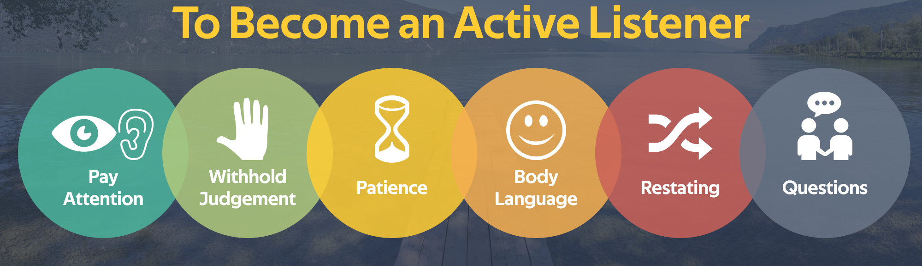
- Active listening involves paying attention to what the other person is saying, not interrupting or thinking how you are going to respond
- Active listening redirects your focus from what is going on inside your head to the needs of the other person
- By facing the other person and asking for clarification, if needed, you are demonstrating that you are interested in what s/he has to say.

Active listening builds rapport and trust and can therefore improve your relationships.

Relationships and Covid-19

The Covid-19 pandemic has changed how we live our lives. Our relationships will be fundamental in helping us cope with these changes. However, these changes may have placed our relationships under strain.

The aim of relationships was never to spend every minute of every day with your partner/family. Any issues prior to Covid-19 may have been heightened due to spending all your time together with no outlet. So give yourself a break if you are finding it challenging. Worrying about family, work, bills etc. will make you less emotionally available to others.

- It is important to remember that every relationship faces challenges now and again
- Being together 24/7, isolation from loved ones and social distancing may lead to anxiety, panic or fear, which make other issues worse
- You may be worrying about how to put food on the table, how to pay bills, mortgage etc or your or a family member’s health
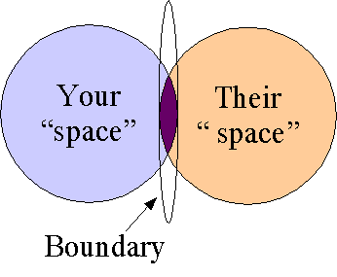
- Difficult conversations may need to be put on hold while you manage the uncertainty in relation to Covid-19
- If you don’t take proactive steps to keep your relationship healthy, it may disintegrate
- One way of maintaining a healthy relationship is maintaining personal boundaries

Relationships and Personal Boundaries
Boundaries that don’t work
- Boundaries that include the words “always or never”
- Boundaries that have a double standard or are manipulative e.g. “You are not allowed to do X but I can do it when I please” or “If you do not agree to our rules, we will exclude you from our will”
- Boundaries that are vague e.g. “Don’t spend a lot of money this month” or “You could pick up the children from school some times”

Exercise Five – What impact has Covid-19 had on your significant relationship(s)?
............................................................................................................................................................
............................................................................................................................................................
............................................................................................................................................................
............................................................................................................................................................
............................................................................................................................................................
............................................................................................................................................................
............................................................................................................................................................
............................................................................................................................................................
............................................................................................................................................................

SETTING BOUNDARIES
- Many people don’t even talk about their boundaries
- They expect the other person to just know them
- This is ineffective and it creates confusion and can damage your relationship

Boundaries that Don’t Work
- Boundaries that include the words “always or never”
- Boundaries that have a double standard or are manipulative e.g. “You are not allowed to do X but I can do it when I please” or “If you do not agree to our rules, we will exclude you from our will”
- Boundaries that are vague e.g. “Don’t spend a lot of money this month” or “You could pick up the children from school some times”

Exercise Six - Thinking about your significant relationship(s)....Did you explicitly set personal boundaries? Do you engage in unhelpful boundaries?
............................................................................................................................................................
............................................................................................................................................................
............................................................................................................................................................
............................................................................................................................................................
............................................................................................................................................................
............................................................................................................................................................
............................................................................................................................................................
............................................................................................................................................................
............................................................................................................................................................

Setting Healthy Boundaries
- Be self-aware e.g. what do you like, dislike?
- Be clear about your needs e.g. do you want to be treated as an equal/an adult/with respect?
- Be specific and direct e.g. “I want to hear how you got on today but give me 30 minutes and you will have my undivided attention”

Exercise Seven - Thinking about your significant relationship(s)....Think about what boundaries are important to you that you wish to convey to the other person.
............................................................................................................................................................
............................................................................................................................................................
............................................................................................................................................................
............................................................................................................................................................
............................................................................................................................................................
............................................................................................................................................................
............................................................................................................................................................
............................................................................................................................................................
............................................................................................................................................................

Exercise Eight - What have your learned today? Try to think of at least 3 key points you have learned.
............................................................................................................................................................
............................................................................................................................................................
............................................................................................................................................................
............................................................................................................................................................
............................................................................................................................................................
............................................................................................................................................................

HOMEWORK

Homework is an important element of CBT treatment. It allows you to try out new techniques and practice coping strategies in between sessions.
- Try to catch any toxic thought patterns when communicating with your significant others over the next week and record these to identify any patterns
- Choose one toxic behaviour that you are aware of and try to change this over the
next week
- Use the 7 Column Thought Record to challenge any Type 2 thoughts you identified
today and any you have over the next week, particularly those linked to anger,
blame or resentment
- Try to practise active listening when engaging in conversations with others
- Try to identify your own personal boundaries you want to set

Date/Time/Situation | Emotions (rate 0-10) | Thoughts | Evidence Supporting Thought | Evidence Disputing Thought | Balanced Thought | Emotions

