Relationships and Mental Health Course – Week Two
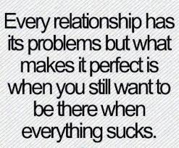
All relationships go through difficult times and there may be occasional problems and conflict. However, sometimes these can become overwhelming.
Relationship Problem Causes
- Attachment
- Abuse
- Environment
- Change in circumstances
- Difference of opinion
- Illness – physical or mental
- Work
- Trust
- Money
Exercise One – Thinking about your most important relationship(s)....What causes do you think are at the root of your problems?
......................................................................................................................................................
......................................................................................................................................................
......................................................................................................................................................
......................................................................................................................................................
......................................................................................................................................................
......................................................................................................................................................
......................................................................................................................................................
......................................................................................................................................................
.....................................................................................................................................................
Attachment
Insecure Attachment
- Avoidant
- Ambivalent
- Disorganised

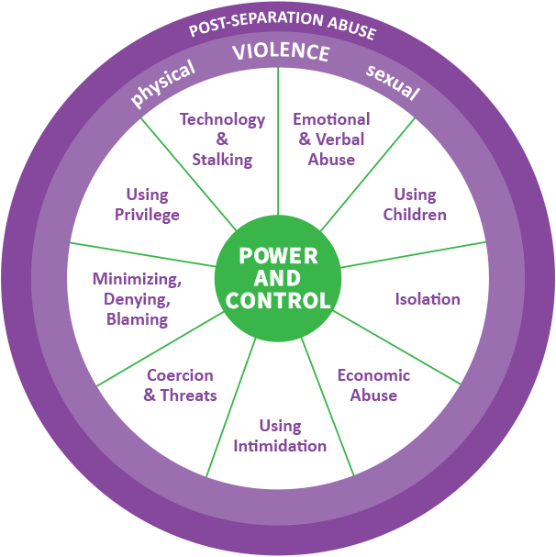
Abuse - If the behaviour is unacceptable to one person in the relationship, then it is a problem.
- Physical abuse
- Emotional/Psychological abuse
- Sexual abuse
- Financial/Economic abuse
- Coercive control
- Tech abuse
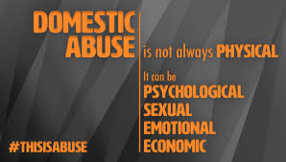
Signs you may be in an abusive relationship:- (Women’s Aid, 2019)
- Your partner stops you from seeing friends/family
- Your partner makes it hard for your to work/study
- Your partner follows you or constantly checks up on you
- Your partner accuses you of having affairs/flirting with others
- Your partner belittles/criticises/humiliates and/or insults you
- You are afraid of your partner
- You change your behaviour for fear of what your partner may say/do
- Your partner deliberately destroyed your possessions
- Your partner hurt or threatened you and/or your children
- Your partner kept you short of money and you were unable to buy food for yourself and your children or take out a loan
- Your partner forced you to do something you did not want to do
- Your partner stopped you taking necessary medication or seeking medical help when you needed it
- Your partner threatened you by telling you that you could be deported because of your immigration status
- Your partner threatened to take your children away or threatened to refuse to let you take them or see them if you left him/her
- Your partner forced you to have sex with him/her and/or other people. S/he made you participate in sexual activities that you were uncomfortable with
- Your partner tried to prevent you leaving the house
- Your partner blames his use of alcohol and/or drugs and/or mental health condition and/or family history for his/her behaviour
- Your partner controls your use of alcohol or drugs e.g. by forcing your intake or by withholding substances

If you answer yes to one or more questions, you may be in an abusive relationship.

If you need help, contact:-
- Scottish Women’s Aid on 0131 226 6606 or
- Abused Men in Scotland on 0808 800 0024 or
- Galop National LGBT+ Helpline on 0800 999 5428.

Environment
Our environment has a significant impact on us and how we interact in our relationships.
An unhealthy environment can be caused by:-
- An negative relationship (personal or work)
- Low self-esteem
- Lack of self-care

Change in circumstances

Relationships can suffer due to a change in circumstances, even positive changes.

Some common changes may be:-
- Starting or graduating from university
- Leaving home
- Getting a new job or promotion
- Getting married/moving in with a partner
- Having a baby
- Ill health
- Retirement
- Bereavement

These changes may result in commitment changes due to new priorities and relationships can suffer.

Difference of opinion

Having different opinions on big issues can sometimes lead to relationship problems. Some common issues may be:-
- Religion
- Politics
- Cultural issues
- Personal goals/values

Ill Health

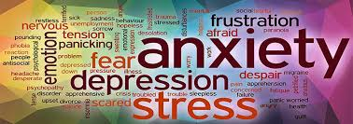
Having poor health (physical and/or mental) can result in a person struggling to engage with others.

You may become resentful if a family member with health problems is seen to behave in an unacceptable manner but they are never challenged on this due to their illness.
Also, you may become resentful if you now have to care for a family member due to their ill health.

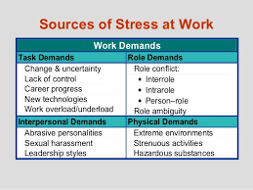
Work

Work can be problematic in relationships for a number of reasons.

If you are stressed at work, you may not have time for family/friends at the end of the work day.

If you are a couple, there may be a difference of opinion about whose work is most important. One partner may be the breadwinner and work long hours or you may work opposite hours for childcare needs.

Struggling at work due to stress and pressure or being in a demanding job takes its toll and you may not feel able to shout at your boss but instead are irritable and snappy with family and/or friends.

Trust

Having a secure attachment when growing up will make it easy for you to trust others. However, an insecure attachment will result in your struggling to trust others.
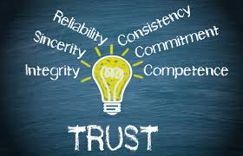
You may fear:-
- Being taken advantage of/manipulated
- Being humiliated
- Being abused (physically or emotionally)
- Being rejected

Money

In intimate relationships, if the couple have different ideas of how to manage money, this can be problematic. Lying about expenditure, not talking about how to manage money and not planning for unexpected bills etc can be detrimental to the relationship.

In family relationships, money may be loaned/borrowed without clear terms of whether or when this will be paid back. One sibling may resent another who frequently borrows from parents.

In friendships, loaning/borrowing money can lead to problems if this money is not repaid as agreed or there are no firm agreements put in place about how and when it will be repaid.

Exercise Two – Thinking about your most important relationship(s)....Which of the root causes or problems are having an impact?
............................................................................................................................................................
............................................................................................................................................................
............................................................................................................................................................
............................................................................................................................................................
............................................................................................................................................................
............................................................................................................................................................
............................................................................................................................................................

PROBLEM BEHAVIOURS
- Avoidance
Growing up with an insecure attachment may result in your fearing intimacy and therefore avoiding closeness in relationships (social and intimate).

Closeness in relationship(s) exposes us to vulnerability and has the potential to evoke strong emotions. The avoidant person subconsciously denies the need for closeness.

The avoidant person has learned to ignore and deny their own negative emotions so they are unlikely to recognise these in others.

Exercise Three – Thinking about your most important relationship(s)….Are you or others avoidant?

............................................................................................................................................................
............................................................................................................................................................
............................................................................................................................................................
............................................................................................................................................................

- Communication Issues
Intimidation - one sided
Parental stance - critical, judgmental, domineering,
condescending
Childish stance - submitting, seeking approval
Non verbal - not a problem as such, however, if it does not match what is being said, this causes confusion and may lead to conflict

Communication is 7% verbal, 38% tone of voice and 55% body language (Yaffe, 2011)

Exercise Four – Thinking about your own communication style with your partner/family/friends/colleagues....Do you engage in any of the previously noted ways?
............................................................................................................................................................
............................................................................................................................................................
............................................................................................................................................................
............................................................................................................................................................
............................................................................................................................................................
............................................................................................................................................................
............................................................................................................................................................
............................................................................................................................................................
............................................................................................................................................................
- Conflict

Conflict usually arises from differing needs/beliefs/values about the relationship.

Conflict Management Styles

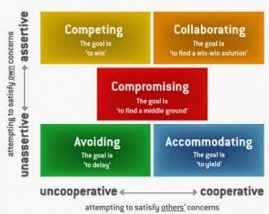
Exercise Five – Thinking about your relationship....How do you deal with conflict?
............................................................................................................................................................
............................................................................................................................................................
............................................................................................................................................................
............................................................................................................................................................
............................................................................................................................................................
............................................................................................................................................................
............................................................................................................................................................

............................................................................................................................................................

Interference from in-laws/friends

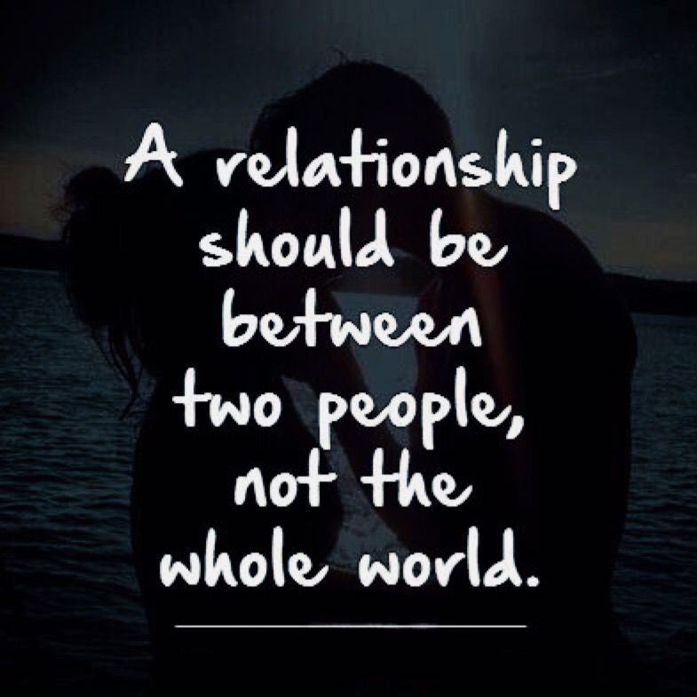
In-laws
3/4 couples experience significant conflict with their in-laws. Mother-in-law/daughter-in-law are the most difficult. 60% of women compared with 15% of men report a negative relationship with their mother-in-law. (Terri Apter, Cambridge University Psychologist)
Friends
Although friends can be a good sounding board, they are not qualified to give you advice. Doing so assumes they are better at problem solving than you and results in them taking some responsibility for your relationship. Remember, friends may have a different view/belief from you about what a relationship should be like.
Couple unity should take priority over any other relationships. If something needs to be said, it should be of the child of the parents and not the in-law.
How do you respond to relationship problems?
- Passive Please others
- Passive Aggressive Say yes but complain and no intention to doing what you say
- Aggressive Making demands of others, ignoring their needs
- Assertive Clearly asking for what you want, respect yourself and others

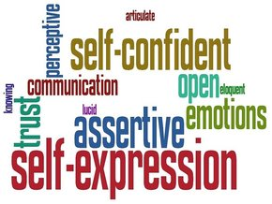
Assertiveness
- Assertiveness is the ability to communicate opinions, thoughts, needs, and feelings in a direct, honest, and appropriate manner.
- Assertiveness involves standing up for your rights in a manner that does not offend others or deny the rights of others.
- When you are assertive you have more control over your life.
- You also make it less likely that other people will take advantage of you.

Exercise Six – Rules of Assertion. In your handout (page 14), tick the rules that you already apply in your relationships.
............................................................................................................................................................
............................................................................................................................................................
............................................................................................................................................................
............................................................................................................................................................
............................................................................................................................................................
............................................................................................................................................................
............................................................................................................................................................

............................................................................................................................................................

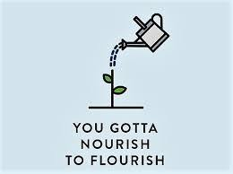
Signs your Relationship is Not a Priority
- Person prioritises others first
- Person chooses to work despite having made plans to meet you
- Person frequently cancels your plans or doesn’t turn up
- Person only contacts you when they are in crisis or have a problem

A relationship is like a garden; it needs constant care and attention in order to flourish and grow.

Exercise Seven – Thinking about your most important relationship(s)....Is it a priority to each of you? If not, what are the signs to indicate this?
............................................................................................................................................................
............................................................................................................................................................
............................................................................................................................................................
............................................................................................................................................................
............................................................................................................................................................
............................................................................................................................................................
Relationship Problems and Avoidance
Avoidance is a way of reducing our worries and fears by:
- Not facing up to the situations we fear
- Escaping the situations we fear

It’s natural to avoid the things that makes us fearful or worried.
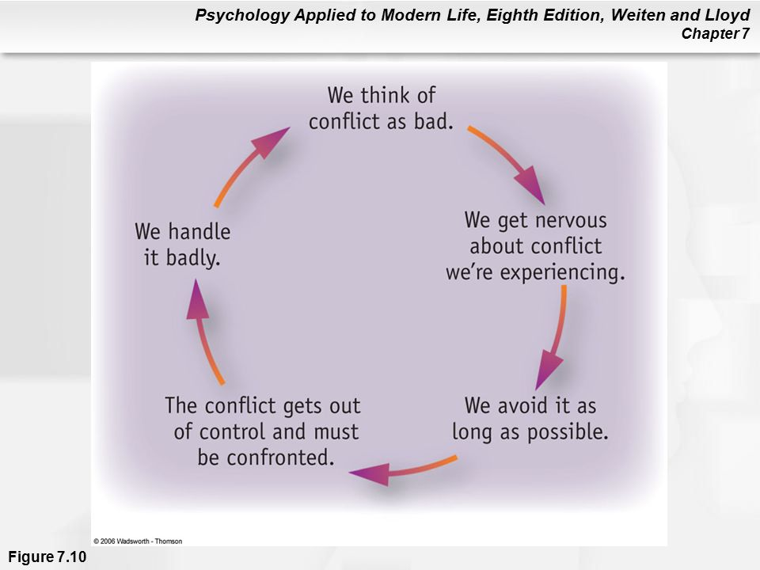
Disadvantages of Avoidance
- It is a short-term solution
- It prolongs the original problem
- It prevents us from learning that our thoughts may not be
true
- It can easily become a habit
- It can start to affect other areas of our life
- It reduces our confidence and self-esteem
- It can lower our mood or increase our anxiety/stress

Graded Exposure – Step by Step
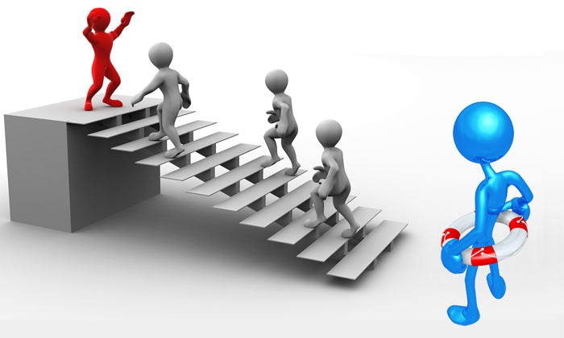

Example Graded Exposure Plan
Behaviour/Activity | Step
Make a note of the reasons I am unhappy with my relationship with my mother | 1
Talk to partner/confidant to get his/her advice on these issues | 2
Make a note of anything that I can do to change any of these issues | 3
Type up a note with each point and bullet points of the main issues I want to discuss | 4
Type up possible ways of resolving each issue | 5
Call mum and suggest we meet to discuss issues impacting our relationship | 6
Agree a mutually convenient time to meet | 7
Meet with mum | 8
Ask mum what she would like to discuss first, raise issues I want to discuss, discuss how we can both resolve these issues | 9
Review what happened, considering what went well and what I would do differently in future | 10

Exercise Nine - Complete a graded exposure plan to achieve one of your desired
goals.

Behaviour/Activity | Step
 | 1
 | 2
 | 3
 | 4
 | 5
 | 6
 | 7
 | 8
 | 9
 | 10

Exercise Ten - What have your learned today? Try to think of at least 3 key points you have learned.
............................................................................................................................................................
............................................................................................................................................................
............................................................................................................................................................
............................................................................................................................................................
............................................................................................................................................................
............................................................................................................................................................
............................................................................................................................................................
............................................................................................................................................................
............................................................................................................................................................

HOMEWORK
Homework is an important element of CBT treatment. It allows you to try out new techniques and practice coping strategies in between sessions.

- For the Rules of Assertion that you have not applied, select one and try to practice using this over the next week.

- Use the Graded Exposure Plan to manage any issues which you have been avoiding.

Rules for Assertion - Exercise Six
Task: Think about how much you follow each of these rules. Which rules do you need to improve on?
I have the right to: | I already follow this | I need to improve on this
1. Respect myself for who I am and what I do | Yes No | Yes No
2. Recognise my own needs and wants as an individual, independent of others. | Yes No | Yes No
3. Make it clear that others understand what I feel and think. For example, "I feel very uncomfortable with that". | Yes No | Yes No
4. Allow myself to make mistakes and realise it is normal to do this. | Yes No | Yes No
5. Change my mind if and when I choose. | Yes No | Yes No
6. Ask for "thinking it over time" if I am not sure. | Yes No | Yes No
7. Allow myself to enjoy my successes and share this with others | Yes No | Yes No
8. Ask for what I want, rather than waiting for someone to offer | Yes No | Yes No
9. Recognise that I am not responsible for the behaviour of other adults. | Yes No | Yes No
10. Respect others and their right to be assertive too. | Yes No | Yes No
11. Say I don't understand. | Yes No | Yes No
12. Deal with others without being dependent on them for approval. | Yes No | Yes No

Graded Exposure Plan to achieve one of your desired goals.

Behaviour/Activity | Step
 | 1
 | 2
 | 3
 | 4
 | 5
 | 6
 | 7
 | 8
 | 9
 | 10

