RELATIONSHIPS AND MENTAL HEALTH COURSE – WEEK ONE
A relationship is the way two or more people (or things) are connected or the state of being connected.
The first relationship we have is with our primary caregiver (generally our mother). The bond established in this relationship tends to shape how we relate to others in adulthood.
A secure attachment allows us to feel safe, manage our emotions and develop healthy relationships in adulthood.
An insecure attachment may leave us feeling unsafe, we may avoid close emotional relationships or we may be critical or blaming.
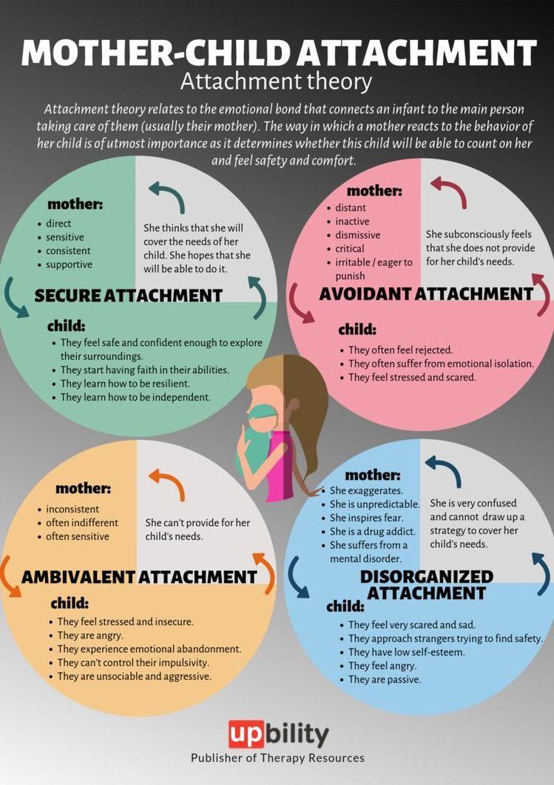

Relationship Development – Attachment
A secure attachment is developed when the infant’s needs are met by the caregiver e.g. the infant feels safe when the mother responds to their cries and accurately interprets their changing needs.

An insecure attachment is a result of the infant’s needs not being met by the caregiver e.g. the infant’s cries and needs may not be met or responded to or the caregiver may be inconsistent in their care giving.

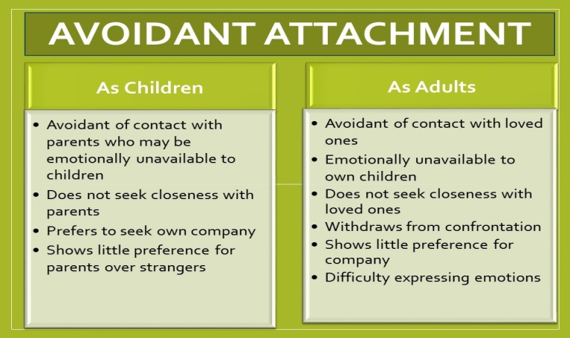
Attachment Impact as Adults
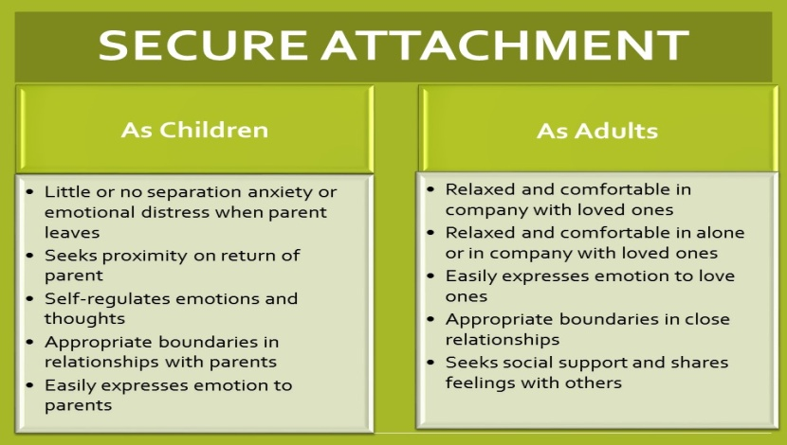
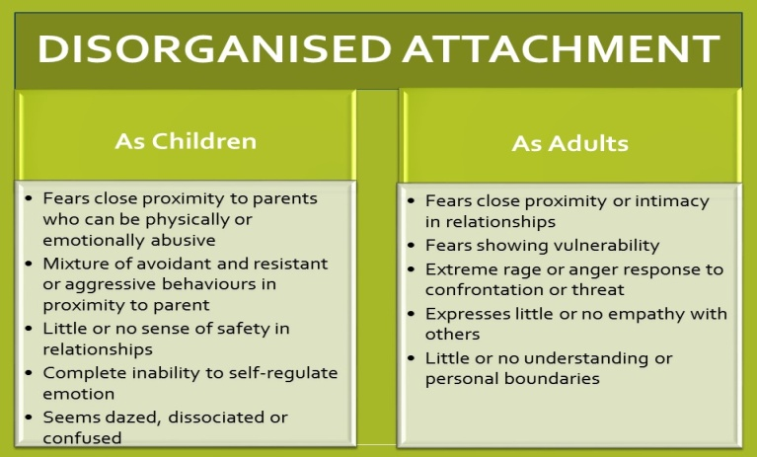
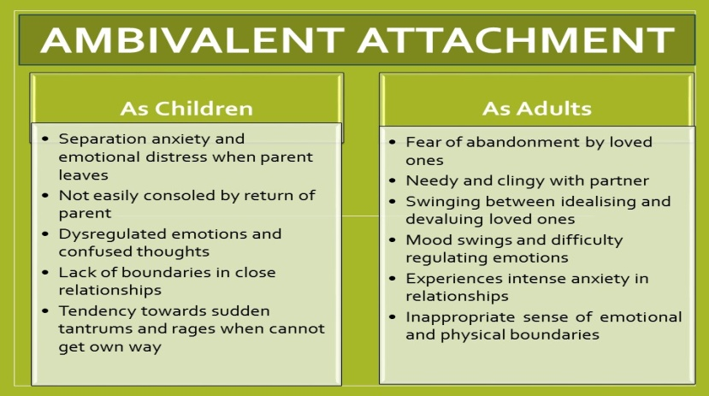
Why do Relationships Matter?
People who are isolated or socially excluded tend to be less happy. Their health and brain function declines earlier than others and as a consequence they die sooner. (Robert Waldinger, Director of Harvard Study of Adult Development.)
Exercise One – Make a note of the significant relationships in your life.
............................................................................................................................................................
............................................................................................................................................................
............................................................................................................................................................
............................................................................................................................................................
............................................................................................................................................................
............................................................................................................................................................
............................................................................................................................................................
............................................................................................................................................................
............................................................................................................................................................

Important Aspects of a Relationship
- Connectedness
- Communication
- Transparency
- Respect
- Responsibility
- Patience
- Humour

Exercise Two – Thinking of your most important relationship(s).... What aspects of the relationship are important to you?
............................................................................................................................................................
............................................................................................................................................................
............................................................................................................................................................
............................................................................................................................................................
............................................................................................................................................................
............................................................................................................................................................

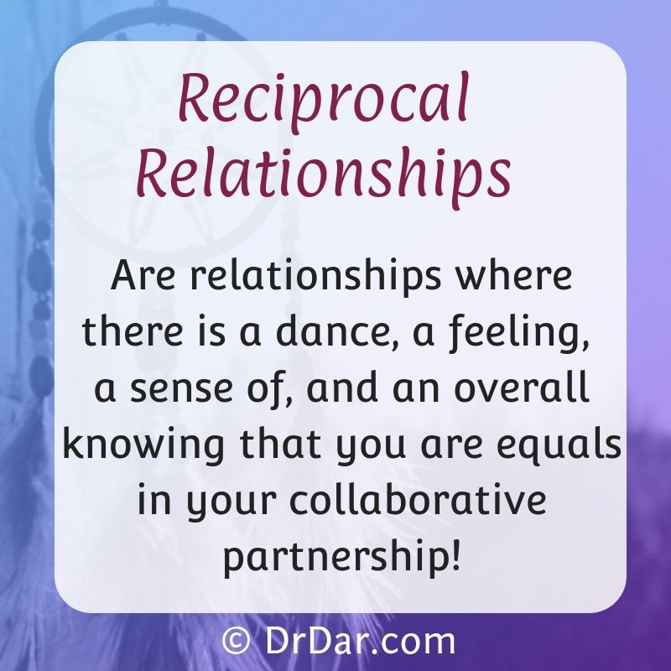
Reciprocal Relationships

In any relationship, we look for this to be reciprocal e.g. equal amount of give and take.

This may not be actually stated but just taken for granted e.g. we expect our families, friends, acquaintances, neighbours and work colleagues to be supportive and treat us with respect. We should offer the same support and respect to them.

Exercise Three – Thinking of your most important relationship(s).... Are these reciprocal?
............................................................................................................................................................
............................................................................................................................................................
............................................................................................................................................................
............................................................................................................................................................
............................................................................................................................................................
............................................................................................................................................................

DIAGRAM OF A CONFLICT (Scottish Marriage Care, 2010)

WHAT TRIGGERS THE ARGUMENTS?
MONEY SEX COMMUNICATION
Alcohol/drugs Children Religion Housework Careers Recreation In-laws

PATTERNS AND PROBLEMS
Poor problem solving Poor listening/communication Anger issues Blaming
Kitchen sinking Drama Triangle Pursuer/Pursuer Withdrawer/Withdrawer Pursuer/Withdrawer

DEEPER HIDDEN ISSUES
Needing and Caring Commitment and Trust Control & Power Integrity Recognition
My emotional needs are Are you going to stay? Who is in charge? You question You do not value or recognise
not being met. You do Who decides? You my intent and what I bring to this relationship.
not care enough for me. can’t control me. I my motives.
only feel safe when
I am in control.

Exercise Four – Thinking of your most important relationship(s).... Make a note of what triggers your arguments. See if you can identify patterns and problems. Think about what the hidden issues may be.
............................................................................................................................................................
............................................................................................................................................................
............................................................................................................................................................
............................................................................................................................................................
............................................................................................................................................................
............................................................................................................................................................
............................................................................................................................................................
............................................................................................................................................................
............................................................................................................................................................

Drama Triangle

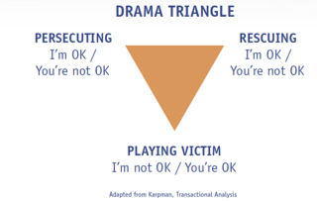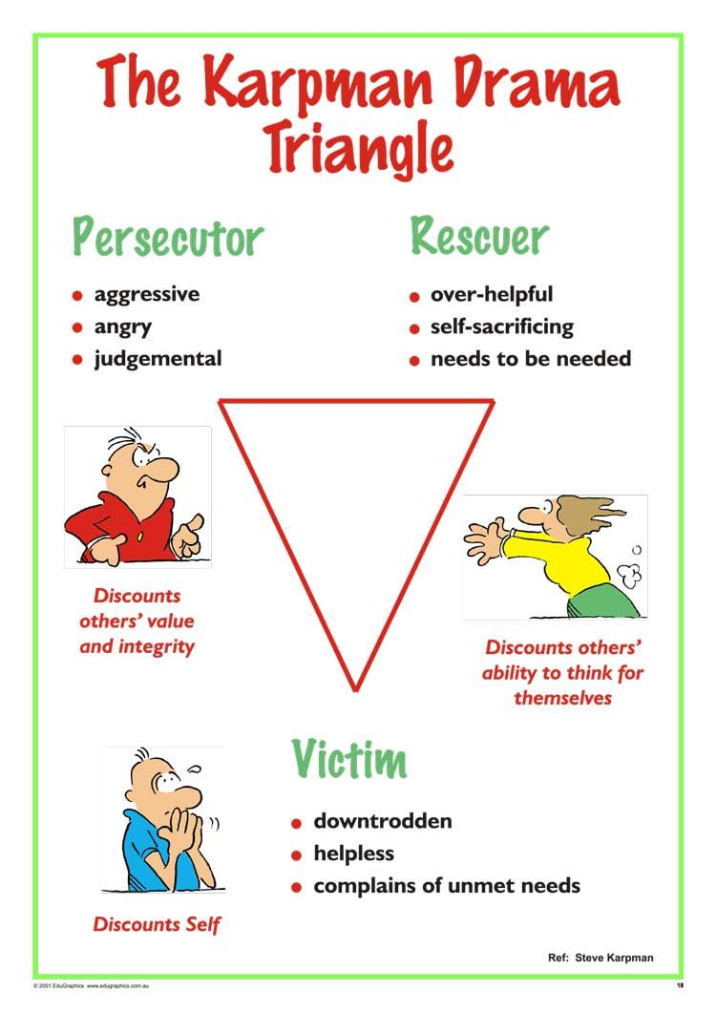

Persecutor – tends to blame and criticise others without providing guidance, assistance or offering a solution to the underlying problem.
Rescuer – tends to enable or disable others by doing things for them that they could/should do for themselves.
Victim – tends to see themselves as powerless, incapable and helpless. Tend to feel defective and want “kid gloves” treatment.

Exercise Five – Thinking of your most important relationship(s).... What roles do you take in the drama triangle?
............................................................................................................................................................
............................................................................................................................................................
............................................................................................................................................................
............................................................................................................................................................
............................................................................................................................................................
............................................................................................................................................................
............................................................................................................................................................

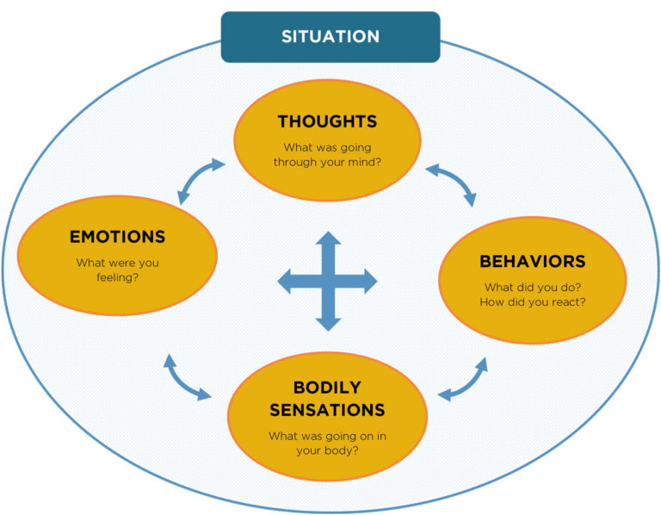
CBT cycle

CBT CYCLE OF RELATIONSHIP PROBLEMS.
Situation – colleague says “have you not finished that job yet?”.
Thoughts – “S/he thinks I am taking too long, s/he thinks I am not pulling my weight, I should have been quicker, I’m not as good as others, I am a failure”.
Emotions – sad, anxious, worried, angry, depressed.
Physical symptoms – heart racing, lump in throat, struggle to focus, loss of appetite, comfort eat.
Behaviours – withdraw, sulk, become tearful, seek reassurance.

PHYSICAL IMPACT OF RELATIONSHIP STRESS
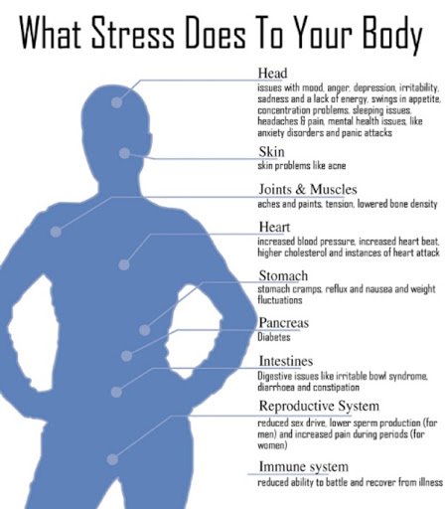
Exercise Six - Make a note of a recent issue and complete the CBT cycle for the impact of that issue, paying particular attention to the physical symptoms you experienced.
Situation............................................................................................................................................
............................................................................................................................................................
Emotions...........................................................................................................................................
............................................................................................................................................................
Thoughts...........................................................................................................................................
............................................................................................................................................................
Behaviour..........................................................................................................................................
............................................................................................................................................................
Physical symptoms .........................................................................................................................
............................................................................................................................................................

HOW TO MANAGE PHYSICAL IMPACT OF RELATIONSHIP STRESS
Relaxation
- Controlled Breathing
- Progressive Muscle Relaxation
- Imaginal Relaxation

Controlled Breathing

- Place one hand on your chest, and one on your stomach
- Imagine a balloon in your stomach
- Breathe in counting 1…2…3 slowly (you should notice when you breathe in, your stomach should move out slightly as if the balloon was inflating)
- Breathe out counting 1…2…3 slowly (you should notice when you breathe out your stomach should move in slightly as if balloon was deflating)
Tips for Practice
- Focus on your breathing – counting 1,2,3 or saying the word ‘relax’ to yourself.
- Practise controlled breathing many times before using it to control the symptoms of stress – you may find it takes many attempts before you are able to breathe calmly when you feel stressed.
- It is a good idea to practise this technique when you do not feel stressed so that you can use it easily when you do experience stress.

Progressive Muscle Relaxation

https://www.youtube.com/watch?v=1nZEdqcGVzo

Imaginal Relaxation

Imagine that you are in a safe/relaxing place - focusing on experiencing all of the senses in this place.

https://www.youtube.com/watch?v=UcFEMPRrGdE

RELAXATION AUDIOS AND APPS
- www.wellbeing-glasgow.org.uk.
- 5 minute relaxation app
- Breathe 2 relax app

Exercise Seven – What can you do to manage your physical symptoms? Make a note of the ways in which you can manage your physical symptoms.
............................................................................................................................................................
............................................................................................................................................................
............................................................................................................................................................
............................................................................................................................................................
............................................................................................................................................................
............................................................................................................................................................
............................................................................................................................................................

Exercise Eight – What are the key elements you have learned today on this course? (Try to identify at least three.)
............................................................................................................................................................
............................................................................................................................................................
............................................................................................................................................................
............................................................................................................................................................
............................................................................................................................................................
............................................................................................................................................................
............................................................................................................................................................

HOMEWORK

Homework is an important element of CBT treatment. It allows you to try out new techniques and practice coping strategies in between sessions.

- Practice breathing and relaxation techniques daily.
- Use a relaxation monitoring diary to record your stress levels before and after practice.

RELAXATION MONITORING DIARY
Date and Time | Type of Relaxation  e.g. Controlled Breathing, Progressive Muscle Relaxation, Guided Imagery | Stress/Anxiety before  0 – 10 (0 = not at all anxious, 10 = most anxious) | Length of Time  e.g. 5 minutess, 20 minutes | Stress/Anxiety after  0 – 10 (0 = not at all anxious, 10 = most anxious)

