COPING WITH LOSS COURSE – WEEK ONE

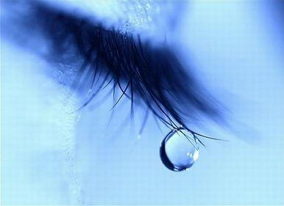
Grief is the universal emotional, cognitive and behavioural response to a significant loss. Most individuals think of the death of a loved one, however we can also experience grief following the loss of e.g. a job, status, our health, a relationship, a precious belonging. There is no right way to grieve, our experiences are individual.

Bereavement refers to the state of the loss (being bereaved) although people often use grief and bereavement interchangeably.
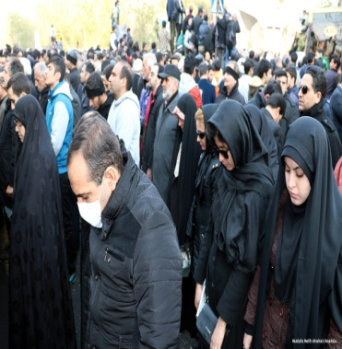
Mourning is the social expression of grief, which enables the bereaved to accept the loss and begin to adapt to the day-to-day changes as a consequence of the loss.

Five Stages of Grief (Elisabeth Kübler-Ross, 1969)

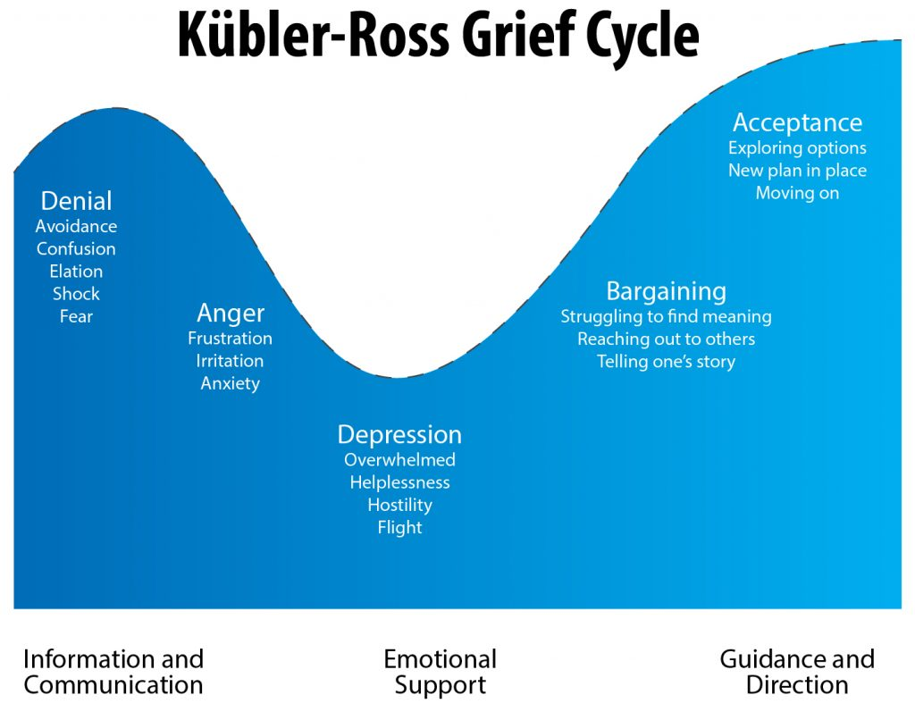
Exercise 1 If grief is manageable, what do you hope to be able to do? (Think about changes you wish to make in the following areas – physical health, mental health, home and family, social life and relationships, work, spiritual development.)

.......................................................................................................................................
.......................................................................................................................................
.......................................................................................................................................
.......................................................................................................................................
.......................................................................................................................................
.......................................................................................................................................
.......................................................................................................................................
.......................................................................................................................................
.......................................................................................................................................

Acute grief is the first stage following notification of the death.

Integrated grief is when you have accepted your loss and resumed normal functioning e.g. returned to work and social activities.

Complicated grief is no different to acute grief. The intensity and duration of emotions are prolonged and considered abnormal according to one’s culture.

Grief and Gender

Biological differences
- One side of brain processes emotion and the other thoughts
- Men more likely to express grief from thoughts and women from emotions

Historical differences
- Men were considered the hunter and provider and are therefore more likely to problem solve (practical)
- Women seen as carers and nurturers and are more likely to seek out support of others

Cognitive Behavioural Therapy (CBT) Vicious Cycle
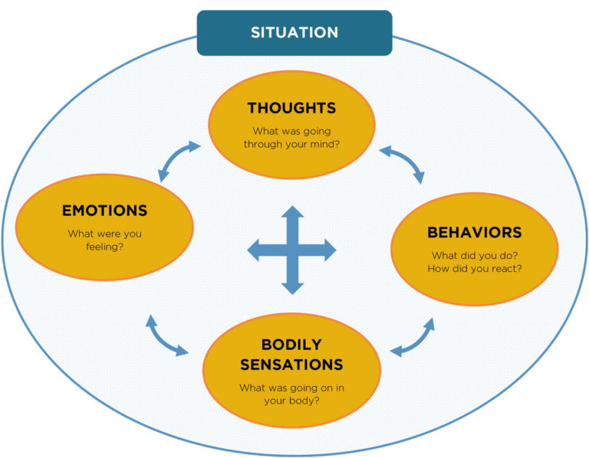

Common physical symptoms experienced when grieving
- Heart problems
- Lowered immune system – more at risk of cold/’flu’
- Aches and pains
- Headaches
- Digestive problems
- Disturbed/lack of sleep
- Fatigue/Exhaustion

Exercise 2 List all the physical symptoms you are currently experiencing

.......................................................................................................................................
.......................................................................................................................................
.......................................................................................................................................
.......................................................................................................................................
.......................................................................................................................................
.......................................................................................................................................
.......................................................................................................................................
.......................................................................................................................................
.......................................................................................................................................

Exercise 3 List ways in which you can manage your physical symptoms (controlled breathing, progressive muscle relaxation, imaginal relaxation, exercise)

.......................................................................................................................................
.......................................................................................................................................
.......................................................................................................................................
.......................................................................................................................................
.......................................................................................................................................
.......................................................................................................................................
.......................................................................................................................................
.......................................................................................................................................
.......................................................................................................................................

HOMEWORK

- Practice breathing and relaxation techniques daily. Use a relaxation monitoring diary to record how you feel before and then after you practise these techniques.

- Aim to engage in some form of exercise, at least 3 days per week

