COPING WITH LOSS COURSE – WEEK FIVE

Exercise 1 List examples of thoughts you have had in relation to Grief in the last week. Then try to label them as Type 1 or Type 2 worries.

.......................................................................................................................................
.......................................................................................................................................
.......................................................................................................................................
.......................................................................................................................................
.......................................................................................................................................
.......................................................................................................................................
.......................................................................................................................................
.......................................................................................................................................
.......................................................................................................................................

Exercise 2 Go back to your answers for Exercise 1 – Can you identify any unhelpful thinking styles?

.......................................................................................................................................
.......................................................................................................................................
.......................................................................................................................................
.......................................................................................................................................
.......................................................................................................................................
.......................................................................................................................................
.......................................................................................................................................
Perception
- It is not usually the situation itself that makes us feel upset/distressed it is our perception of that situation…
- Our perception can be based upon past experiences
- Changing the way we think about situations and seeing different perspectives can help us to feel less upset/distressed and more in control

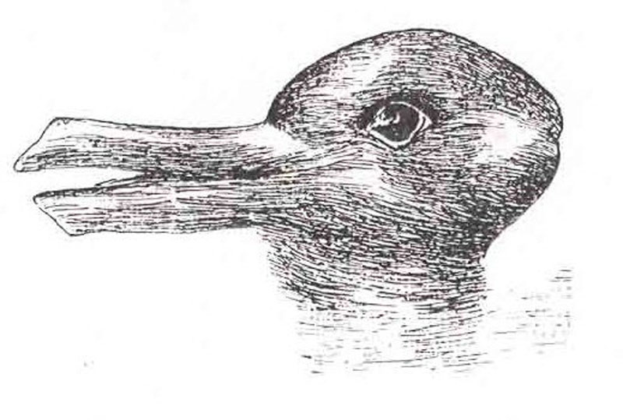
7 Column Thought Diary - Example
Date/Time/Situation | Emotions (rate 0-10 | Thoughts | Evidence Supporting Thought | Evidence Disputing Thought | Balanced Thought | Emotions
Monday morning, 10am,  Having breakfast at home on my own, sent a text to Carol to cancel meeting up today | Sad 9/10  Guilty 10/10 | I can’t cope with company just now  If I start crying I won’t stop  I shouldn’t have cancelled with Carol  I am a bad friend | I have cancelled with Carol three times now | I am grieving  I have cancelled with other people too  I don’t usually cancel with Carol  Carol has had to cancel with me in the past | I am not a bad friend  I am a friend who is struggling right now  Carol understands and will still be my friend | Sad 7/10  Guilty 4/10  Relieved 5/10
Exercise 3 Use this 7 Column Thought Diary to challenge one of your Type 2 worries from Exercise 1

Date/Time/Situation | Emotions (rate 0-10 | Thoughts | Evidence Supporting Thought | Evidence Disputing Thought | Balanced Thought | Emotions

Other Impacts of Grief on Thoughts
- Disbelief (I only spoke with him/her an hour ago)

- Guilt (I should have, I could have, If only...)

- Anger/Blame (It’s ..... fault, s/he made a mistake) (Type 2)

- Confusion (struggle to order thoughts, difficulty concentrating, forgetful)

- Preoccupation (intrusive thoughts/images of the individual dying)

How to Manage These Thoughts

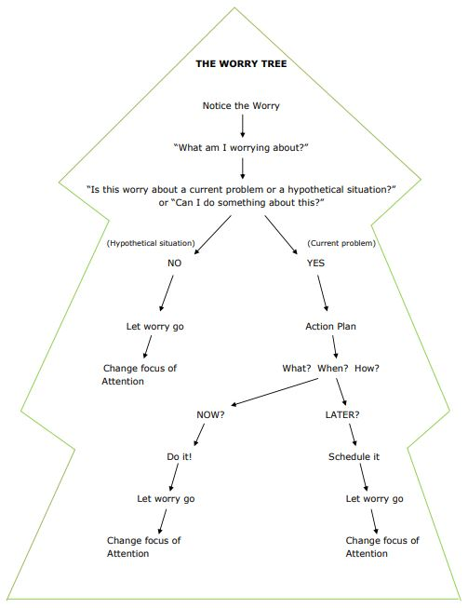
If you answer “yes” to “Can I do something about this?” then follow Problem Solving Technique.

- Exercise
- Relaxation
- Mindfulness
- Listen to music
- Talking to family/friends
- Writing to do lists for the day/week
- Write a list of people you can contact
- Write a list of favourite restaurants/places

POSTPONING WORRY

STEP 1 SET A WORRY TEIM
- Choose a specific time, length of time and a place to do all your thinking about worrisome things e.g. 6pm for 20 minutes in the spare room.
- The time should be convenient so you can keep your worry time the same everyday - try not to set your worry time close to bedtime as this can impact on your ability to sleep.
- If it does need to be changed on a certain day, just make sure you have a clear idea of the time you have rescheduled it to.
- Make the place unique, comfortable and free from distractions.
STEP 2 POSTPONE YOUR WORRY
- Whenever you notice yourself worrying during the day, postpone it to the worry period.
- Note your worry briefly on paper or ‘phone.
- Remind yourself that you will have time to think about it later, no need to worry about it now. You will be in a better position to deal with the worry in the worry period.
- Turn your focus to the present moment and the activities of the day to help let go of the worry until the worry period has arrived.
- If the thought pops back again (which it likely will), this is not a sign that postponement hasn’t worked. After all we can’t control what pops into our head!
The aim is to stop the engagement with the thought that results in spiralling or snowballing of those thoughts.
STEP 3 COME BACK TO YOUR WORRY
- When your worry period comes around, settle in your chosen place and take some time to reflect on the worries you had written down from the day.
- Only worry about the things you have noted if you feel you must. Don’t think about them if they no longer bother you, or no longer seem relevant. You could just cross them off your list.
- If you do need to worry about some of them, spend no longer than the set amount of time you specified for your worry period.

Exercise 4 Controlling Worry
On a scale of 0-10, with 0 meaning ‘I have no control’ and 10 meaning ‘I have complete control’, how much do you believe that you can control the time you spend worrying?

0…………………………………………………………………………10

ATTENTION TRAINING

- Worry is generally future focused
- We miss out on the present
- Pay less attention to the task in hand
- Attention training can help improve our focus on the here and now
- It can reduce preoccupation with worries

Exercise 5 Practice of Attention Training in Session

That issue that I asked you to think about, how much attention were you giving it during that exercise (0-100%)?

How worried do you feel at this moment (0- 10) scale?

Did anything change?

Exercise 6 List the key points you have learned today.

.......................................................................................................................................
.......................................................................................................................................
.......................................................................................................................................
.......................................................................................................................................
.......................................................................................................................................
.......................................................................................................................................
.......................................................................................................................................
.......................................................................................................................................
.......................................................................................................................................

HOMEWORK

- Try to identify the Unhelpful Thinking Styles in your unhelpful thoughts and see if there is a pattern.

- Use the 7 Column Thought Record to challenge any Type 2 thoughts you identified today and any you have over the next week.

- Use the Worry Tree to help you manage your worries. Record your outcomes on the sheet provided.

- Use the Postpone Your Worry Technique and record your results on the sheet provided.

- Practice the Attention Training Technique and record the outcome on the sheet provided.

