Week 4
Coping strategies and techniques

Session 4
- Controlled Breathing
- Progressive muscle relaxation
- Imaginal relaxation
- Mindfulness
- Worries
- Thinking styles
- Challenging thoughts
- Worry time

Recap – Activity logs and activity scheduling

Last week we discussed low mood and depression and the importance of pleasant activities or activities that give you a sense of achievement.
These could be on your own or with your baby.
Last week we discussed low mood and depression and the importance of pleasant activities or sense of achievement.

Exercise
How did you get on with the activity schedule?
Anything you noticed?
Consider what you need to work on or if you could try differently.
Discuss how you got on.

What were the barriers? – time, lack of sleep etc
Problem solve how to overcome barriers?
Share ideas with each other...

In the first 3 sessions we have looked at how becoming a parent can impact on your mental health and wellbeing.
We are now going to look at a range of coping skills and strategies.
We know it is hard to relax with a baby but consider any ideas you could use – even if it’s just a small idea or goal.

We are now going to look at a range of strategies and coping skills/techniques to help manage stress and anxiety. You may have already tried some of them.

Recap – Controlled Breathing
Remember
- Keep your shoulders still, don’t let them move up
- Stomach should expand, not your chest!

Place one hand on your chest,
and one on your stomach so you can feel
your stomach expand. Imagine a balloon
in your stomach and picture it expanding
as you breath in.
Breathe in slowly and count to 5......
Then breathe out through your mouth slowly counting to 5....
Then keeping repeating this....

Or alternatively – square breathing

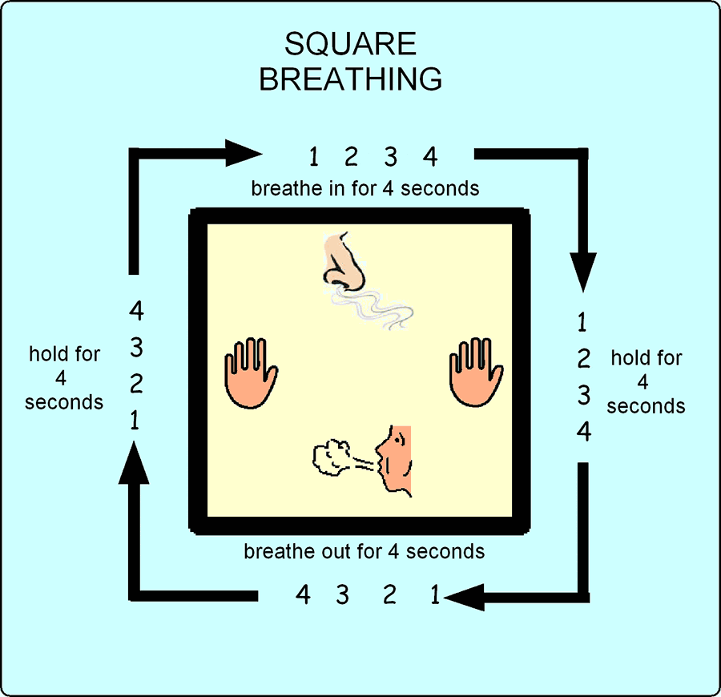

Progressive Muscle Relaxation

When anxious or stressed our bodies tense up.
Therefore something called progressive muscle relaxation can help.
This is when you tense and then relax different muscle groups in your body.
You will also find audios on our website or on some of the recommended apps.

Imaginal relaxation

You can use imaginal relaxation to help you relax at anytime, or before going to sleep at night.
Close your eyes and imagine a place where you feel relaxed - this can be a real place you’ve been or somewhere in your imagination or that you know about.
Try to notice all the senses – What can you See? Hear? Feel? Taste? Smell?
Use your controlled breathing techniques as well to feel more relaxed.
When you are ready, open your eyes and become aware of where you are and your surroundings.

Mindfulness
- Is when we pay attention to the present moment, not the past or future which we often concentrate on
- Instead of having a head full of worries it’s about noticing what is going on around you in the present moment
- Notice thoughts, feelings, sights, sounds, taste (senses)
- Just 5-10 minutes a day can be beneficial
- Has benefits for you and your baby!

See the relaxation mindfulness and meditation videos and audios on our website. Also see the list of recommended apps.

- Even trying to spend 5 minutes per day doing some mindfulness can bring benefits.

Types of worry

Type 1. Worry about current issues,
a problem that exists
e.g. “what will I do for childcare
when I go back to work?”
Type 2. Worry about potential or hypothetical things that haven’t happened
e.g. “What if…..I damage my baby, ..I get my baby taken off me”….
Type 3. Worry about worrying
e.g. “worrying is going to make me ill”
Exercise
Types of worries
Exercise - Do you worry about practical things or hypothetical worries? About yourself, your partner or baby?
What kind of worries have you notice you have?
Remember these thinking styles from last week: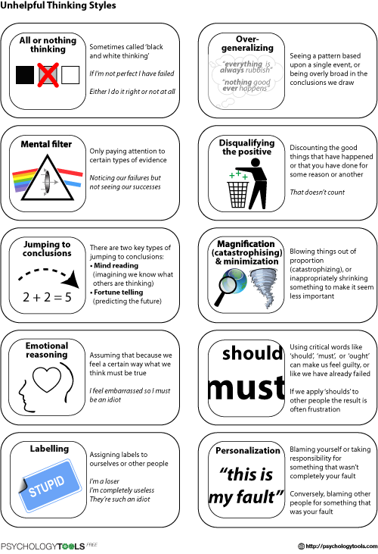
Exercise
Types of thinking
What types of thinking have you noticed you have?
Write down any examples.

Challenging negative thoughts

If you notice you are having these types of thoughts it can be helpful to speak to someone else about it and use techniques such as trying to stop and think to yourself:
‘what evidence do I have for this thought?
‘are there any other ways of looking at this situation?’
‘are your judgements based on how you felt rather that what you did?’
‘how would someone else think about the situation?’
‘are you setting yourself an unrealistic standard?’
‘are you forgetting some facts and only focusing on irrelevant facts?’
‘are you thinking in all-or-nothing terms?’
‘how will things be in 6 months/a years time?’
‘am I over-estimating how much control I have over how things work out?’
‘are you underestimating what you could do to deal with a situation?

Example
Jane often notices she has feels anxious when out at the shop with her baby.
Her thoughts include:
‘what if he cries and people look like last time’
‘people think I’m a bad mother’
‘I must be a terrible parent’
What are her thinking styles?
What challenging thoughts could she ask herself?

Worry Time
Postponing worry to a set worry time can help
as later in the day it may not feel the same as
when your worries first come into your head.

- Set a timer or build into your daily routine
- Limit your worry time to 15/30 minutes max
- Don’t set the time too close to bed so it’s not the last thing in your head
- Use the worry tree for managing worries
- If you can’t problem solve a worry ‘let it go’ and try to focus on something else
- Try to do when your baby is sleeping if possible or when someone else is watching them.

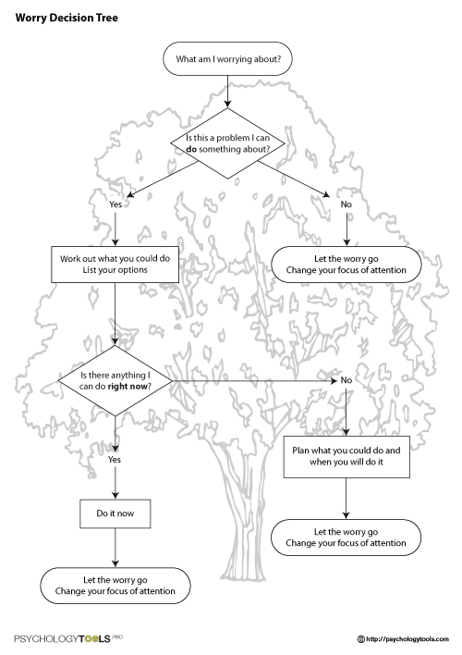
During worry time you can write your thoughts down on a piece of paper or on your phone.
This can help you to rationalise your thoughts or just get it off your chest and try to develop more helpful thoughts.
It is important to try to manage your thoughts so they don’t get out of control.
Try to challenge your thinking and looking for small positives or achievements can help build up your confidence and avoid comparing yourself to others.

What we’ve covered today

- Controlled Breathing
- Progressive muscle relaxation
- Imaginal relaxation
- Mindfulness
- Worries
- Thinking styles
- Challenging thoughts
- Worry time

Well done for completing week 4!
Over the coming week be alert and aware of your thinking styles and if possible start to challenge them or try out worry time.
Also continue to use relaxation techniques or mindfulness and plan small achievable activities.

